A000-Asia-China-Liangzhu-Jade-Trapezoid-Pei Figure-3200 BCE

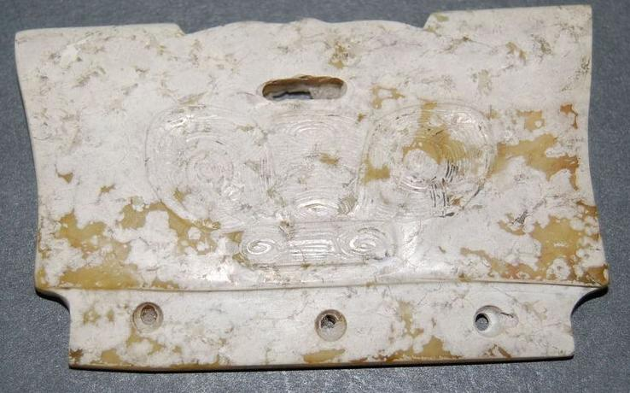

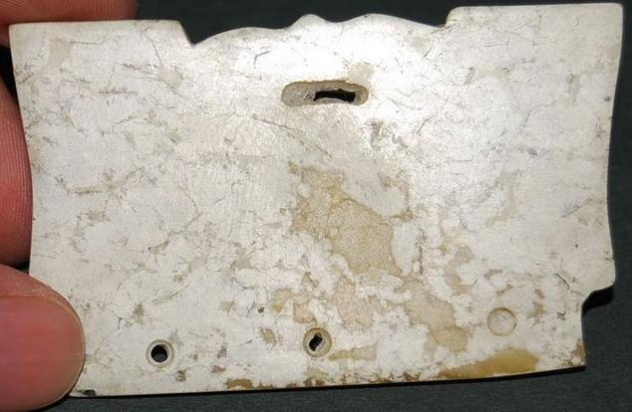

Figs 1-2. China-Liangzhu-Jade-Trapezoid-Pei Figure-3200 BCE

Case no.: 5

Accession Number:

Formal Label: China-Liangzhu-Jade-Trapezoid-Pei Figure-3200 BCE

**Display Description:** This jadeTrapezoid-Pei Figure has a cartouche-like panel representing an anthropomorphic shamanic mask suggesting meditation on this disk would induce a shamanic trance. This iconography undoubtedly harkens back to a pre-Neolithic period when shamanic imagery was the symbolism of hunter-gatherers and was the imagery that was inscribed on petroglyph panels. Indeed, Hayashi Minao argues that the name of the cong/tsung derived from zhu/chu meaning "master" which we expand to "master of animal powers" (Hayashi 1990:6).

The ritual paraphernalia of the Liangzhu culture that were used in worship in the Neolithic period do not represent spiritual beings in either human or animal shape that were believed to animate nature but were the objects themselves at a time when the concept of the spirit of a thing was not yet separated from the thing itself. In this context this object is a true effigy, the image of the Sun deity and emblazoned on it in bas relief is the image of a son of the Sun, a ruling ancestor whose property this was as it was used in rituals according honor to the Sun in its various seasonal manifestations. In fact, this jade idol corresponds to the oldest form of Chinese graph designating the Sun.

**LC Classification:** NK5750.2.A1

Date or Time Horizon: Liangzhu culture, lower Yangzi River Valley, early Liangzhu Period, ca. 3200 BCE Geographical Area: Liangzhu culture, lower Yangzi River Valley

**Map:**

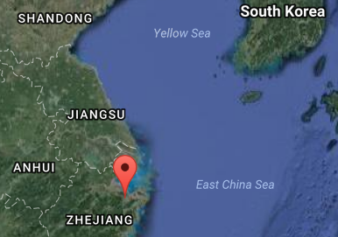

Fig. 3. Source: Google Earth

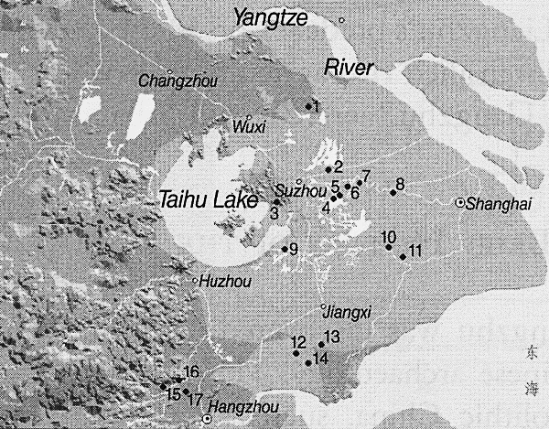

Fig. 4. Detail of Liangzhu site complex surrounding Taihu. After Zhou Ying 2007.

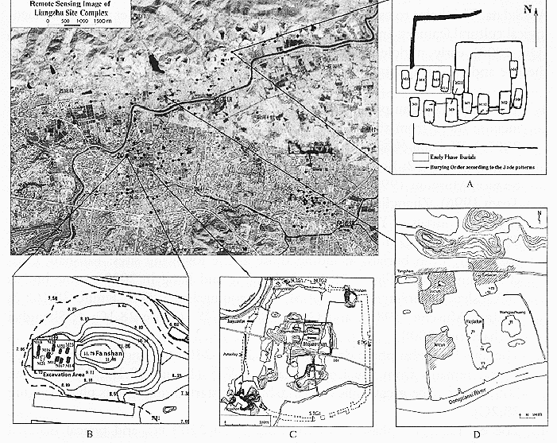

**Fig. 5.** Detail of Liangzhu site proper. After Zhou Ying 2007.

**GPS coordinates:**

Northeast corner: N 30°24'48", E 120°00'17"

Northwest corner: N 30°24'41", E 119°58'58"

Southeast corner: N 30°23'20", E 120 00'19"

Southwest corner: N 30°22'55", E 119°58'28"

Cultural Affiliation: Liangzhu culture, lower Yangzi River Valley, 3300-2250 BCE

Medium: Jade

Cultural Affiliation: Liangzhu

Medium: jade

Dimensions:

Weight:

Condition: original

Provenance:

**Discussion:**

Liangzhu (3400–2250 BCE) in Yuhang County, Zhejiang, was a highly stratified Neolithic jade city-state in the Yangtze River delta where élites controlled a sphere of influence north to Shanxi and south to Guangdong.

DNA recovered from Liangzhu graves shows high frequencies of Haplogroup O1 linking it with modern Austronesians. Hence, Liangzhu is thought to have been the original Austronesian homeland (Freeman Foundation. 2007; Jiao 2007).

The use of jade and other expensive wares (such as silk, lacquerware, and ivory) in grave sites characterized the social symbolism of Liangzhu élites. About 4200 BP Liangzhu succumbed to a series extreme floods since the cultural layers are interrupted by intrusions of mud and sand. It is also possible that an asteroid created Taihu lake 4500 BP, which contributed to its demise.

**References:**

Biot, Jean Baptiste. 1851. *Le Tcheou-li: ou, Rites des Tcheou*. Paris: Imprimerie nationale, 1851. 3v.

Chang, K.C., Xu, P. and Lu, L. 2005. *The formation of Chinese civilization: an archaeological perspective*. New Haven: Yale University Press.

Freeman Foundation. 2007. ["Lost Maritime Cultures: China and the Pacific"](https://web.archive.org/web/20150701020443/http:/www.bishopmuseum.org/exhibits/pastexhibits.html). An exhibit at the Bishop Museum, 2007. See Jiao 2007.

Hayashi, Minao. INCLUDEPICTURE "http://lms01.harvard.edu:80/exlibris/aleph/u20_1/alephe/www_f_eng/icon/f-separator.gif" \* MERGEFORMATINET 林巳奈夫. 1991. *Chūgoku kogyoku no kenkyū*. INCLUDEPICTURE "http://lms01.harvard.edu:80/exlibris/aleph/u20_1/alephe/www_f_eng/icon/f-separator.gif" \* MERGEFORMATINET 中國古玉の研究. Tōkyō : Yoshikawa Kōbunkan; 東京 : 吉川弘文館, 1991.

Hayashi, Mineo. 1990. “On the Chinese Neolithic jade Tsung/Cong,” *Artibus Asiae*, 50(1/2):5-22.

Hayashi, Mineo. 1973. *Toyo Gakuho* [Journal of the Research Dept. of the Toyo Bunko] 45:1-57.

Jiao, Tianlong. 2007. *Lost maritime cultures: China and the Pacific.* Honolulu, Hawai'i: Bishop Museum Press.

Jiao T. “Maritime culture and the prehistory of southeast China.” In Tianlong Jiao*, Lost Maritime Cultures: China and the Pacific*. Honolulu, Hawai'i: Bishop Museum Press, 2007:12-35.

Laufer, Berthold. 1912. *Jade a study in Chinese archaeology and religion*. Field Museum of Natural History, Publication 154, Anthroplogical series, vol. X. Chicago.

Li, Hui; Huang, Ying; Mustavich, Laura F.; Zhang, Fan; Tan, Jing-Ze; Wang, Ling-E; Qian, Ji; Gao, Meng-He; Jin, Li. 2007. "Y chromosomes of prehistoric people along the Yangtze River," Human Genetics **122**: 383–388.

Rolett B. “Southeast China and the emergence of Austronesian seafaring.” In Jiao, Tianlong. 2007. *Lost maritime cultures: China and the Pacific.* Honolulu, Hawai'i: Bishop Museum Press.

Wu, Li. 2014. "Holocene environmental change and its impacts on human settlement in the Shanghai Area, East China," Catena. **114**: 78–89

Zhang, Chia; Hsiao-Chun, Hung. 2008. "The Neolithic of Southern China–Origin, Development, and Dispersal," Asian Perspectives. **47**:2, 309–310.

|  |
| --- |
| Zhou Ying. 2007. 东方文明的曙光: 良渚遗址与良渚文化 = Dong fang wen ming de shu guang : Liang zhu yi zhi yu liang zhu wen hua = *The Dawn of the Oriental Civilization: Liangzhu site and Liangzhu culture*. Beijing: China Intercontinental Press. |